ETL process explanation with key screenshots
- Database set up – Before the ETL process can begin we need to create the data warehouse structure in Postgres. Creating schema and tables.

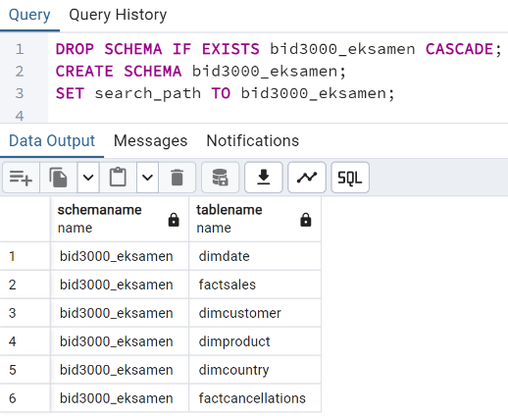

- Database set up – Before the ETL process can begin we need to create the data warehouse structure in Postgres. Creating schema and tables.

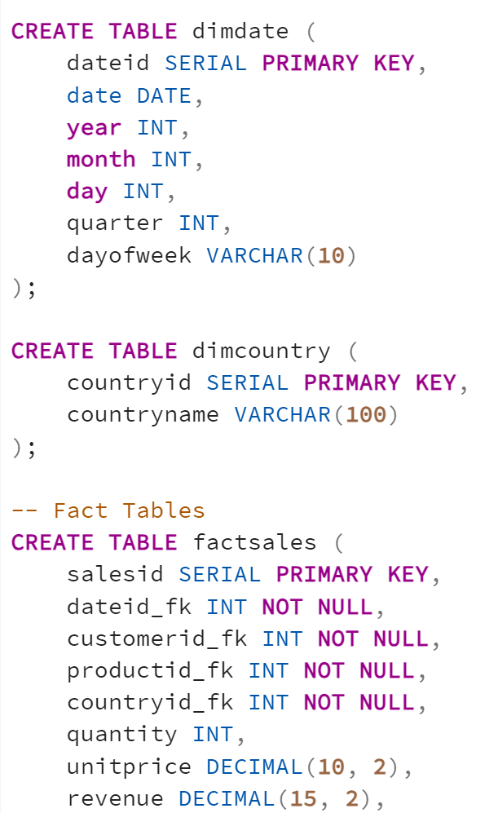

- Database connection: Once the schema is created, the Python ETL script connects to the database with this code:
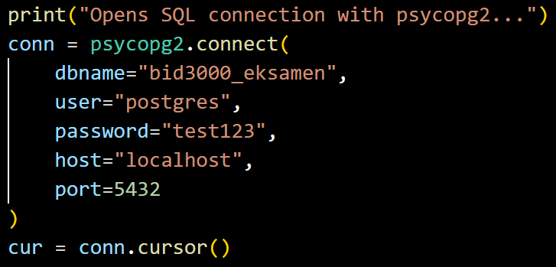

- Extract data from CSV (file df = pd.read_csv('online_retail_II.csv')
Data Source Structure:
InvoiceNo: Transaction identifier
StockCode: Product identifier
Description: Product description
Quantity: Units purchased (negative = cancellation)
InvoiceDate: Transaction timestamp
Price: Unit price
CustomerID: Customer identifier (can be null) -
Country: Customer country
Screenshot: The CSV file contains over 1 million rows, exceeding Excel's display capacity, demonstrating the need for a data warehouse solution.
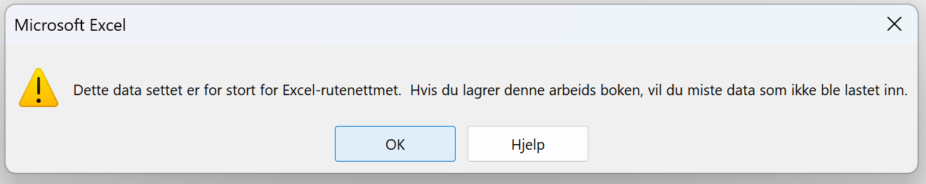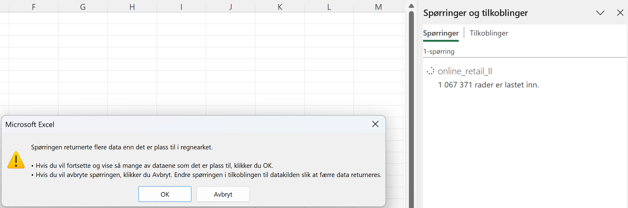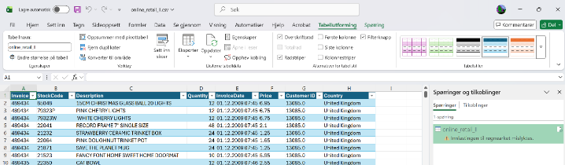But still showing us a lot of data.
Screenshot 1 from Excel showing raw data structure:
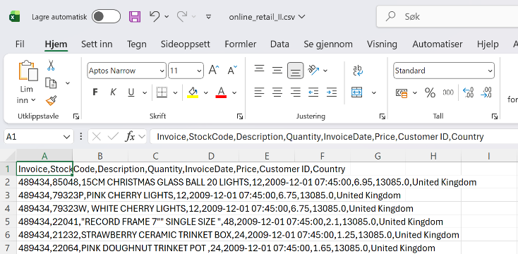

Screenshot from ETL.py showing succesful file read and row count from source file:
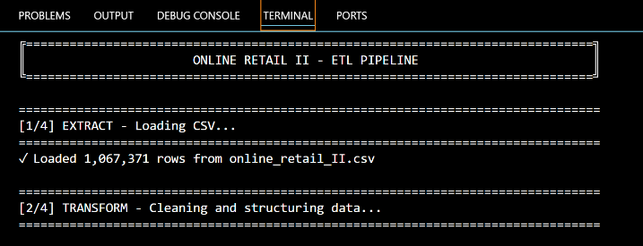

Transform data
The transform phase applies several data quality rules and business logic transformations:
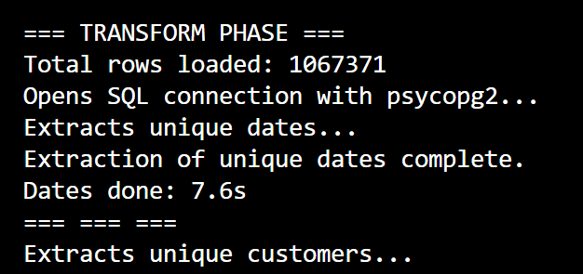
Key transformations applied:
Date conversion: InvoiceDate converted to datetime format
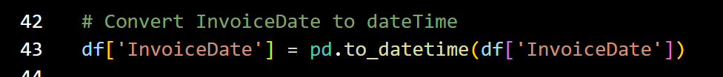
Anonymous customers: NULL CustomerID values mapped to 0
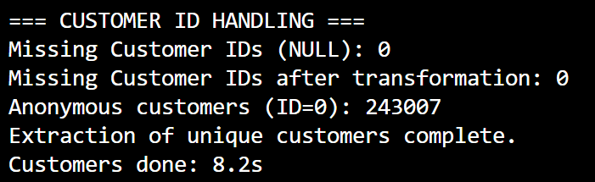
Data quality filtering: Rows with Quantity = 0 excluded (meaningless transactions)
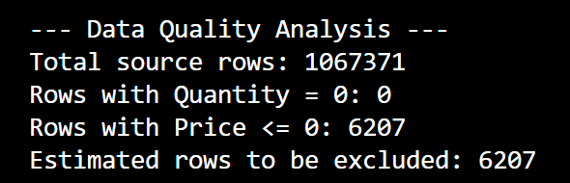
Rows with Price ≤ 0 excluded (data quality issues)
Products without descriptions excluded
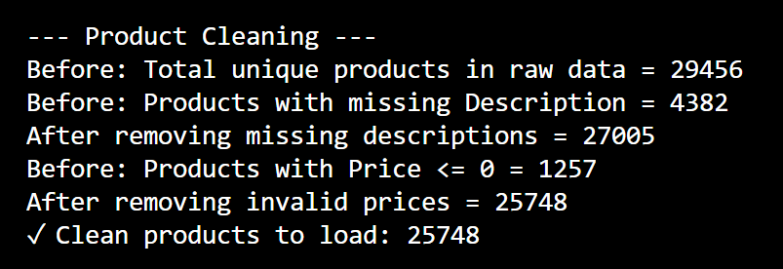

Product descriptions: Cleaned with trim and title case formatting
Business logic: Separated sales (positive quantity) from cancellations (negative quantity)
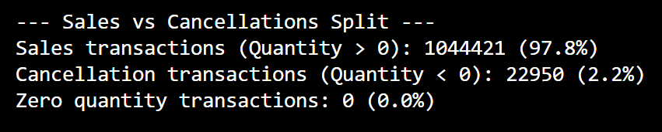

Load
The load phase populates dimension tables first (to establish foreign keys), then loads fact tables:
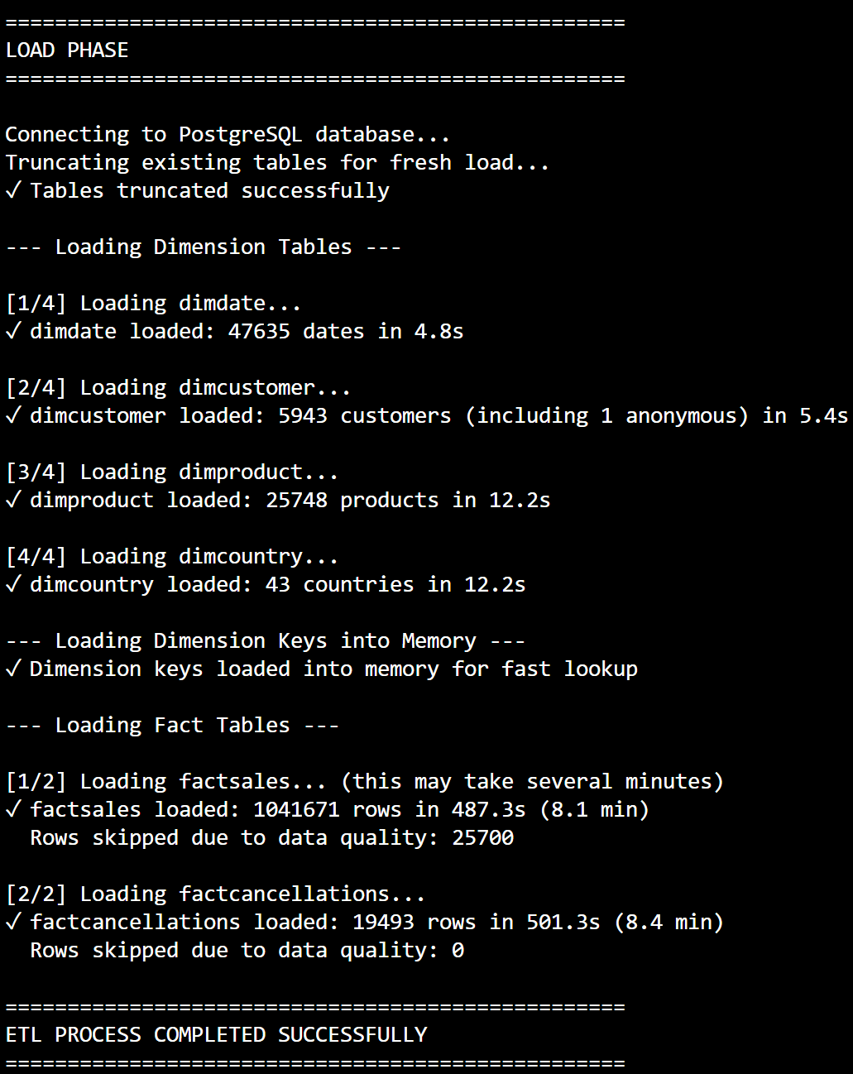
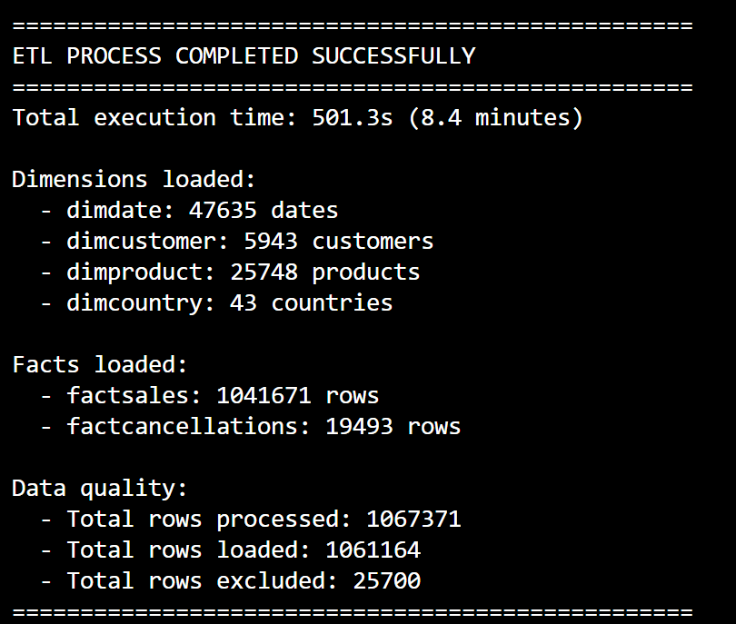

Screenshot showing 6 tables in PostgreSQL:
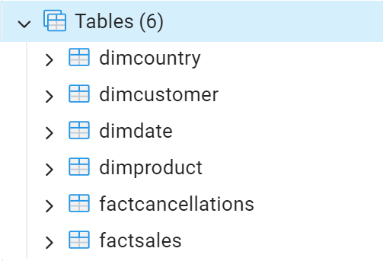
Screenshot showing data loaded in PostgreSQL with all FK and measures (quantity, unitprice, revenue)
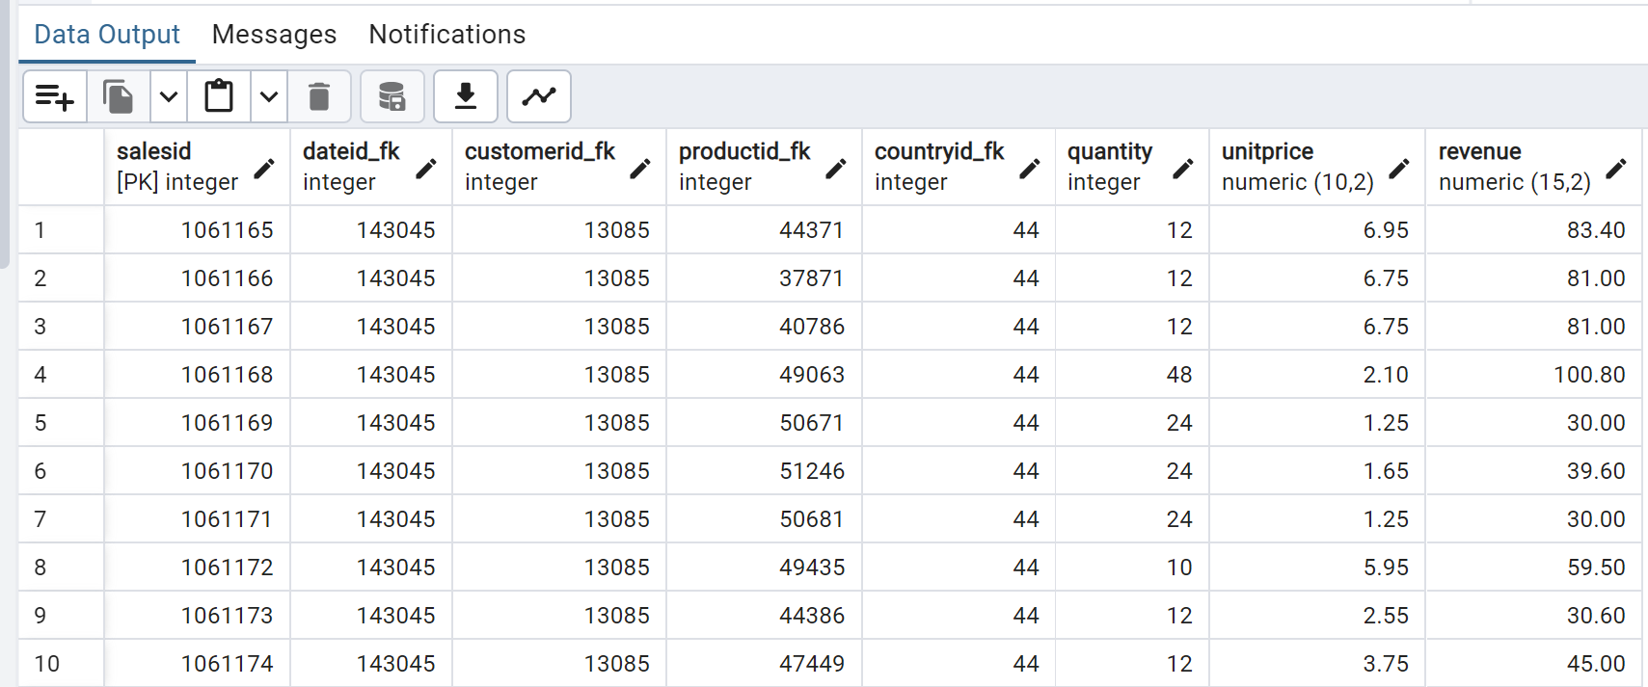
Screenshot of final populated warehouse:
